**CHAPTER-1**

**PROBLEM STATEMENT**

**PROBLEM STATEMENT**

Manual process of scanning IP Address of the system & finding IP Classification, Host ID, Network ID & Host Name is more time consuming & requires more manual power. In order to reduce it we are developing a project IP CLASSIFICATION using C.

**CHAPTER-2**

**INTRODUCTION**

**INTRODUCTION**

An **Internet Protocol address** (**IP address**) is a numerical label assigned to each device participating in a computer network that uses the Internet Protocol for communication. An IP address serves two principal functions: host or network interface identification and location addressing. Its role has been characterized as follows: “A name indicates what we seek. An address indicates where it is. A route indicates how to get there.”

The designers of the Internet Protocol defined an IP address as a 32-bit number and this system, known as Internet Protocol Version 4 (IPv4), is still in use today. However, because of the growth of the Internet and the predicted depletion of available addresses, a new version of IP (IPv6), using 128 bits for the address, was developed in 1995. IPv6 was standardized as RFC 2460 in 1998, and its deployment has been ongoing since the mid-2000s.

IP addresses are usually written and displayed in human-readable notations, such as 172.16.254.1 (IPv4), and 2001:db8:0:1234:0:567:8:1 (IPv6).

The Internet Assigned Numbers Authority (IANA) manages the IP address space allocations globally and delegates five regional Internet registries (RIRs) to allocate IP address blocks to local Internet registries (Internet service providers) and other entities.

**IP versions**

Two versions of the Internet Protocol (IP) are in use: IP Version 4 and IP Version 6. Each version defines an IP address differently. Because of its prevalence, the generic term *IP address*typically still refers to the addresses defined by IPv4. The gap in version sequence between IPv4 and IPv6 resulted from the assignment of number 5 to the experimental Internet Stream Protocol in 1979, which however was never referred to as IPv5.

**IPv4 addresses**

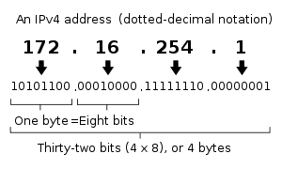

In IPv4 an address consists of 32 bits which limits the address space to 4294967296 (232) possible unique addresses. IPv4 reserves some addresses for special purposes such as private networks (~18 million addresses) or multicast addresses (~270 million addresses).

IPv4 addresses are canonically represented in dot-decimal notation, which consists of four decimal numbers, each ranging from 0 to 255, separated by dots, e.g., 172.16.254.1. Each part represents a group of 8 bits (octet) of the address. In some cases of technical writing, IPv4 addresses may be presented in various hexadecimal, octal, or binary representations.

**Classes of IP addresses**

TCP/IP defines five classes of IP addresses: class A, B, C, D, and E. Each class has a range of valid IP addresses. The value of the first octet determines the class. IP addresses from the first three classes (A, B and C) can be used for host addresses. The other two classes are used for other purposes – class D for multicast and class E for experimental purposes.

The system of IP address classes was developed for the purpose of Internet IP addresses assignment. The classes created were based on the network size. For example, for the small number of networks with a very large number of hosts, the Class A was created. The Class C was created for numerous networks with small number of hosts.

**Classes of IP addresses are:**

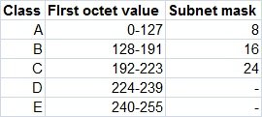

For the IP addresses from Class A, the first 8 bits (the first decimal number) represent the network part, while the remaining 24 bits represent the host part. For Class B, the first 16 bits (the first two numbers) represent the network part, while the remaining 16 bits represent the host part. For Class C, the first 24 bits represent the network part, while the remaining 8 bits represent the host part.

**Introduction of Classful IP Addressing**

IP address is an address having information about how to reach a specific host, especially outside the LAN. An IP address is a 32-bit unique address having an address space of 232. Generally, there are two notations in which IP address is written, dotted decimal notation and hexadecimal notation.

**Dotted Decimal Notation:**

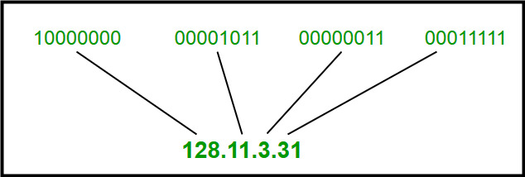

**Hexadecimal Notation:**

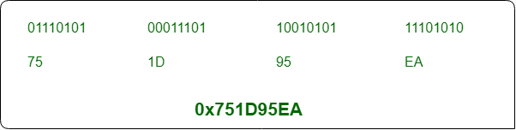

Some points to be noted about dotted decimal notation:

1. The value of any segment (byte) is between 0 and 255 (both included).
2. There are no zeroes preceding the value in any segment (054 is wrong, 54 is correct).

**Classful Addressing**

The 32-bit IP address is divided into five sub-classes. These are:

* Class A
* Class B
* Class C
* Class D
* Class E

Each of these classes has a valid range of IP addresses. Classes D and E are reserved for multicast and experimental purposes respectively. The order of bits in the first octet determine the classes of IP address.

IPv4 address is divided into two parts:

* **Network ID**
* **Host ID**

The class of IP address is used to determine the bits used for network ID and host ID and the number of total networks and hosts possible in that particular class. Each ISP or network administrator assigns IP address to each device that is connected to its network.

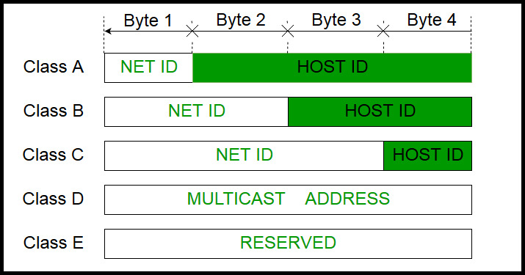

**Note:**IP addresses are globally managed by Internet Assigned Numbers Authority (IANA) and regional Internet registries (RIR).

**Note:**While finding the total number of host IP addresses, 2 IP addresses are not counted and are therefore, decreased from the total count because the first IP address of any network is the network number and whereas the last IP address is reserved for broadcast IP.

**Class A:**

IP address belonging to class A are assigned to the networks that contain many hosts.

* The network ID is 8 bits long.
* The host ID is 24 bits long.

The higher order bit of the first octet in class A is always set to 0. The remaining 7 bits in first octet are used to determine network ID. The 24 bits of host ID are used to determine the host in any network. The default subnet mask for class A is 255.x.x.x. Therefore, class A has a total of:

* 2^7-2= 126 network ID (Here 2 address is subtracted because 0.0.0.0 and 127.x.y.z are special address.)
* 2^24 – 2 = 16,777,214 host ID

IP addresses belonging to class A ranges from 1.x.x.x – 126.x.x.x

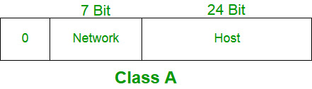

**Class B:**

IP address belonging to class B are assigned to the networks that ranges from medium-sized to large-sized networks.

* The network ID is 16 bits long.
* The host ID is 16 bits long.

The higher order bits of the first octet of IP addresses of class B are always set to 10. The remaining 14 bits are used to determine network ID. The 16 bits of host ID is used to determine the host in any network. The default sub-net mask for class B is 255.255.x.x. Class B has a total of:

* 2^14 = 16384 network address
* 2^16 – 2 = 65534 host address

IP addresses belonging to class B ranges from 128.0.x.x – 191.255.x.x.

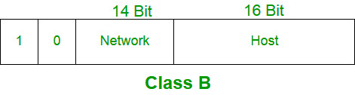

**Class C:**

IP address belonging to class C are assigned to small-sized networks.

* + - The network ID is 24 bits long.
    - The host ID is 8 bits long.

The higher order bits of the first octet of IP addresses of class C are always set to 110. The remaining 21 bits are used to determine network ID. The 8 bits of host ID is used to determine the host in any network. The default sub-net mask for class C is 255.255.255.x.

Class C has a total of:

* + - 2^21 = 2097152 network address
    - 2^8 – 2 = 254 host address

IP addresses belonging to class C ranges from 192.0.0.x – 223.255.255.x.

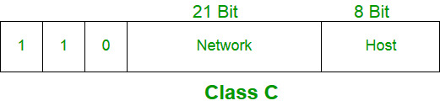

**Class D:**

IP address belonging to class D are reserved for multi-casting. The higher order bits of the first octet of IP addresses belonging to class D are always set to 1110. The remaining bits are for the address that interested hosts recognize.

Class D does not possess any sub-net mask. IP addresses belonging to class D ranges from 224.0.0.0 – 239.255.255.255.

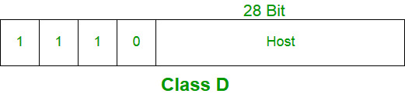

**Class E:**

IP addresses belonging to class E are reserved for experimental and research purposes. IP addresses of class E ranges from 240.0.0.0 – 255.255.255.254. This class doesn’t have any sub-net mask. The higher order bits of first octet of class E are always set to 1111.

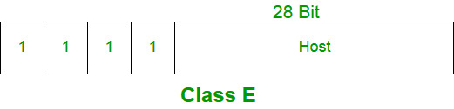

**Range of special IP addresses:**

**169.254.0.0 – 169.254.0.16**: Link local addresses

**127.0.0.0 – 127.0.0.8**: Loop-back addresses

**0.0.0.0 – 0.0.0.8**: used to communicate within the current network.

**Rules for assigning Host ID:**

Host ID’s are used to identify a host within a network. The host ID are assigned based on the following rules:

* + - Within any network, the host ID must be unique to that network.
    - Host ID in which all bits are set to 0 cannot be assigned because this host ID is used to represent the network ID of the IP address.
    - Host ID in which all bits are set to 1 cannot be assigned because this host ID is reserved as a broadcast address to send packets to all the hosts present on that particular network.

**Rules for assigning Network ID:**

Hosts that are located on the same physical network are identified by the network ID, as all host on the same physical network is assigned the same network ID. The network ID is assigned based on the following rules:

* + - The network ID cannot start with 127 because 127 belongs to class A address and is reserved for internal loop-back functions.
    - All bits of network ID set to 1 are reserved for use as an IP broadcast address and therefore, cannot be used.
    - All bits of network ID set to 0 are used to denote a specific host on the local network and are not routed and therefore, aren’t used.

**Summary of Classful addressing:**

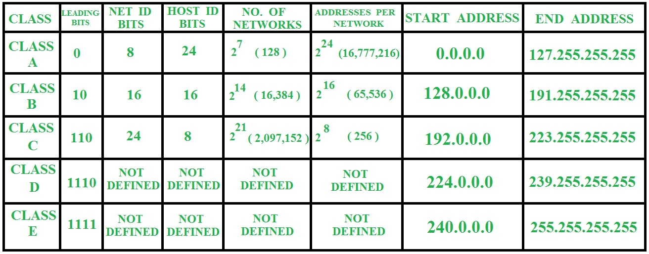

**Problems with Classful Addressing:**

The problem with this classful addressing method is that millions of class A address are wasted, many of the class B address are wasted, whereas, number of addresses available in class C is so small that it cannot cater the needs of organizations. Class D addresses are used for multicast routing and are therefore available as a single block only. Class E addresses are reserved.

**CHAPTER-3**

**PROJECT DESCRIPTION**

**PROJECT DESCRIPTION**

In this project we are developing a C code to get the Host Name & IPv4 Address of the system then defining the class to which the IP belongs to & providing the Host ID & Network ID of the IP Address.

In this program we have various functions to do particular task. Let’s see what the functions are going to perform.

**Predefined Functions:**

* **gethostname():** The gethostname function retrieves the standard host name for the local computer.
* **gethostbyname():** The gethostbyname function retrieves host information corresponding to a host name from a host database.
* **inet_ntoa():** The inet_ntoa function converts an (Ipv4) Internet network address into an ASCII string in Internet standard dotted-decimal format.

**User Defined Functions:**

* **findClass():** The findClass function will find the class of the IPv4 Address.
* **separate():** The separate function will divide the Host ID & Network ID from the IPv4 Address according the class to which the IPv4 belongs.

**CHAPTER-4**

**REQUIREMENTS**

**REQUIREMENTS**

**OPERATING SYSTEM REQUIREMENTS:** Linux Operating Systems (Any Flavour)

**SOFTWARE REQUIREMENTS:** Any C Compiler (e.g. GCC Compiler)

**CHAPTER-5**

**TEST PLAN & TEST CASES**

**TEST PLAN & TEST CASES**

|  |  |  |  |
| --- | --- | --- | --- |
| **Sl. No** | **Test case** | **Expected Output** | **Actual Output** |
| **1** | To check whether it is scanning IP Address or not | IPv4 Address (e.g. 127.0.0.0) | IPv4 Address (e.g. 127.0.0.0) |
| **2** | To check whether it is showing Host Name or not | Host Name of the network (e.g. Bablu) | Host Name of the network (e.g. Bablu) |
| **3** | To check whether IP Classification is occurring or not | Class A/B/C/D/E | Class A/B/C/D/E |
| **4** | To check the Host Id is getting or not | Host ID according to IPv4 Class | Host ID according to IPv4 Class |
| **5** | To check the Network Id is getting or not | Network ID according to IPv4 Class | Network ID according to IPv4 Class |

**CHAPTER-6**

**RESULT**

**RESULT**

**Expected Result:**

Host Name: BabluKavali

Host IP: 127.0.1.1

IP Class: B

Network ID: 127.0

Host ID: 1.1

**CHAPTER-6**

**CONCLUSION**

**CONCLUSION**

In this project, IP Classification is designed using C programming language in order to reduce the manual process of finding the Host Name, IPv4 Address of the system & to determine to which Class the IPv4 belongs & to know what is the Host ID & Network ID of the IPv4 Address.